OLY MESH CORNER GLASS 66x66 W
Corner preformed element in AR fiberglass mesh with anti-alkaline treatment

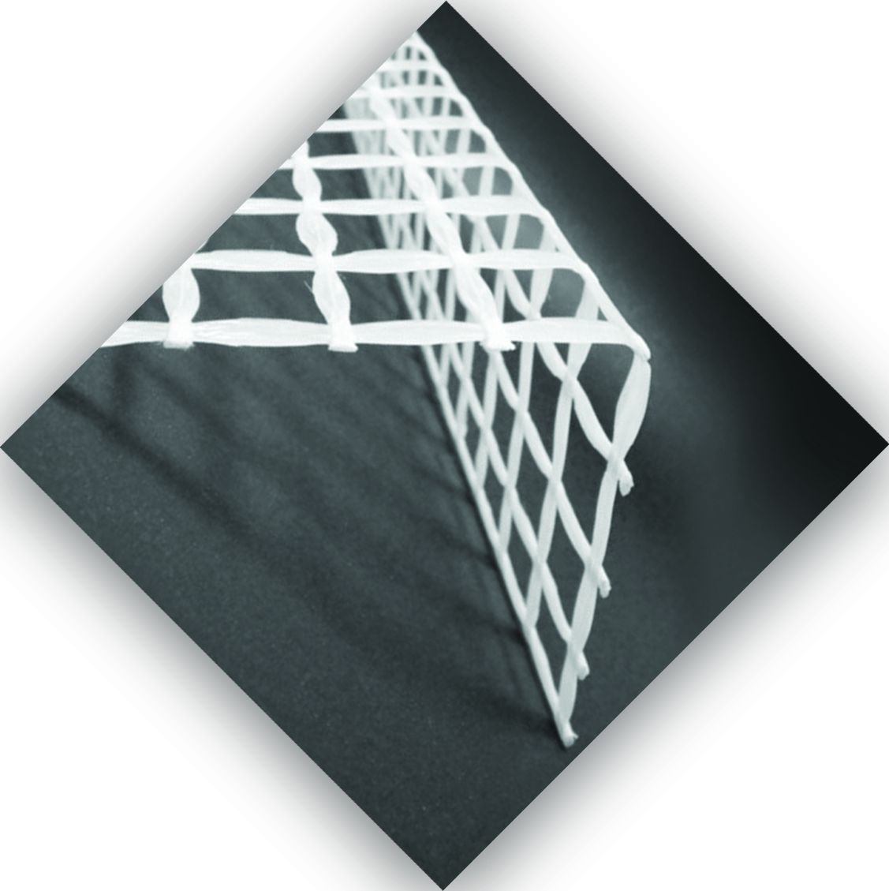 | OLY MESH CORNER GLASS 66x66W is a preformed structural corner in fiberglass with epoxy resin suitable for guaranteeing continuity of mechanical performance of fiberglass networks for structural reinforcements and the consolidation of walls and openings such as windows and doors. The corner complies with the "Guideline for the identification, qualification and acceptance control of preformed mesh systems in fiber-reinforced composite materials with a polymer matrix to be used for the structural consolidation of existing buildings with the CRM reinforced plaster technique ( Composite Reinforced Mortar) "Issued by the CSLLPP Central Technical Service in 2019.

OLY MESH CORNER GLASS 66x66W guarantees excellent mechanical characteristics, allows you to easily remedy precarious situations affecting both vertical structures and horizontals, allowing, unlike interventions made with traditional materials, reduced invasiveness, as they allow to keep the dimensions of the previous elements almost unchanged and their own weight and therefore of the entire structure. Composite materials have undoubted advantages: very high tensile strength, low specific weight, high resistance to environmental stresses. Furthermore, they have the advantage of being applied quickly and minimally invasive. The reinforcement properly placed can be subsequently plastered with traditional plasters on the market.

Technical features
Proprieties OLY MESH CORNER GLASS 66x66W | Nominal value
Mesh size | 66 x 66 mm
Weight | 488 g/m
Bar height | 2 m
Width of the sides | 33 cm
Elongation at break | 2,2 %
Tensile strength of the bar (medium) | 7,2 kN
Tensile strength of the bar (characteristic) | 5,8 kN
Tensile strength of the network (medium) | 108 kN/m
Tensile strength of the mesh (characteristic) | 87 kN/m
Elastic modulus (EN 13412) | 27 GPa

Storage and safety conditions
Store in a covered and dry place;
Use appropriate precautions in handling, transport and storage activities in order to avoid damage;
During the preparation and installation of the reinforcement systems, wear individual protective equipment (head, gloves, goggles and dust masks);
Before installation, the product must be cleaned of dust, oils, greases, etc .;
For more information, refer to the technical sheets of the mortars OLY WALL STRUKTURA.

Packs
The corner is available in bars with a height of 200 cm, with a standard width of 30 + 30 cm.

Installation
- Incorporate the corner element OLY MESH CORNER GLASS 66x66 W in the middle of the layer of mortar, ensuring an overlap of at least 15 cm with the adjacent meshes, in order to guarantee mechanical continuity.
- If the subsequent laying of civil plasters is necessary, a manual dusting with quartz sand should be carried out beforehand on the still “fresh” system to increase the useful bonding surface.

Warnings
The technical and mechanical characteristics and the methods of installation indicated in this sheet are based on an extensive analysis of the state of the art of the research and of the applications in question, but cannot imply any guarantee on our part on the final result of the product. applied in particular with regard to the installation of systems that must be carried out by specialized personnel.
The buyer is responsible for verifying the suitability of the products described in this document for the intended use and purposes. Olympus srl assumes no responsibility for the improper use of the material. The customer is required to verify that this sheet and the data reported therein are valid for the batch of product of his interest and are not outdated as replaced by subsequent editions and / or new product formulations or certifications. The customer is invited to contact our Technical Department in advance for further clarifications. This edition cancels and replaces any previous one.

Product for professional use
Rev. 001-20

For information, technical assistance and additional systems for structural reinforcement, visit the site:
www.olympus-italia.com
E-mail:
info@olympus-italia.com

